**MDA Annual Report**

McMinnville City Council Meeting

April 23, 2019

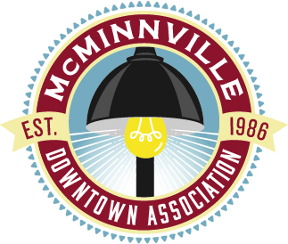

**Past**

* Financial report
* 2018 highlights
  + Electronic gift cards invested $34,000 in the local economy (13% increase over 2017)
  + Find Yourself in Downtown marketing campaign aimed at local residents with an estimate of over 200 thousand views from the MDA website, social media, and print advertising
  + Year round tree lights on Third Street

**Present**

* Strong board and staff
  + Jenny Berg, President (City of McMinnville)
  + Dustin Wyant, Vice President (The Barberry, 1882 Grille)
  + Gerry Hunter, Treasurer (3rd Street Pizza)
  + Casee Clark, Secretary (R. Stuart & Co. Winery and Wine Bar)
  + Tommy Paterson (United Capital)
  + Lucetta Elmer (The Oak, Union Block Coffee, Douglas on Third)
  + Sylla McClellan (Third Street Books, Yamhill Valley Dry Goods)
  + Chelsey Nichol (Type A Press)
  + Dani Chisolm (McMenamins Hotel Oregon)
  + Heather Miller (Local Flow Health Bar)
  + Kate Gowell (Haugeberg, Rueter, Gowell, Fredricks & Higgins, P.C.)
  + Katie Sours (Western Oregon Center for Pediatric Therapeutic Lifestyle Change)
  + Kent Taylor (Retired City Manager)
  + Staff members Tayler Brisbin and Chloe Rasch
* Hiring committee for Executive Director
  + Sylla McClellan
  + Jenny Berg
  + Dustin Wyant
  + Dani Chisolm
  + Chelsey Nichol
  + Kent Taylor
  + Heather Richards
  + Jeff Knapp
  + Scott Cooper
  + Gioia Goodrum

**Future**

* Continuation & stability
* Economic Improvement District renewal
* Events – Farmers’s Market, UFOfest, Concerts on the Plaza

Attachments

* Year end financial statements
* EID Quick Facts