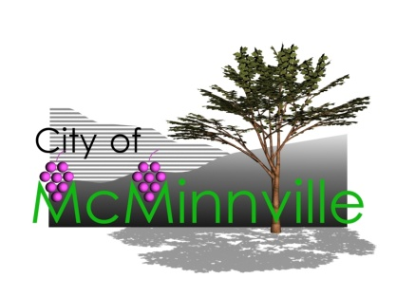

*City of McMinnville*

**2018 Pavement Preservation Program**

*Slurry Seal Project Information*

**Cook School Slurry Seal Preservation Project**

*Type II slurry seal application to the streets in the Cook School area*

***Project Location***

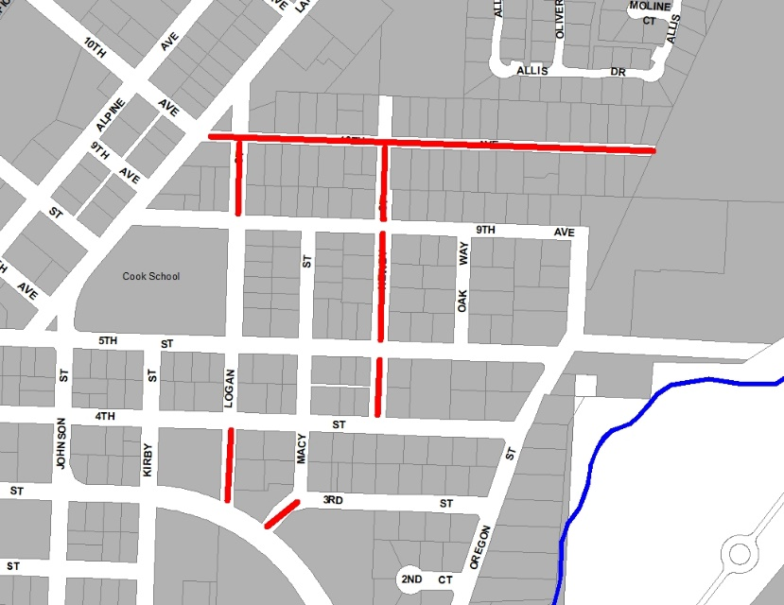Neighborhood streets in the Cook School Area.

***Project Overview***

This project consists of slurry seal application on residential streets in this neighborhood. Slurry seal is a versatile and cost effective way to preserve and protect the street surface; and it will extend the life of the existing roadway by protecting it from the effects of weathering and wear.

***What To Expect***

The slurry seal will be applied on warm, dry days, and the slurry seal will dry in several hours. **On the day of application the street will be closed to all traffic and no parking will be allowed until the new coating is dry**. Watch for construction signs, no parking signs and informational flyers prior to, and as the work progresses.

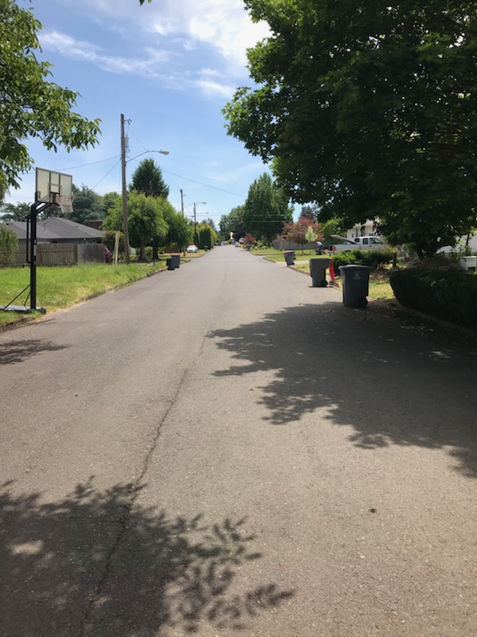***Construction Schedule***

Monday, July 30th and Tuesday, July 31st. Neighborhood notices will be posted prior to the beginning of the project and project schedules mailed to residents.

***Construction Contractor***

Telfer Pavement Technologies, LLC of McClellan, CA. The work will be reviewed and approved by City inspectors.

***Project Cost***

The City is performing street slurry seal work on approximately 2.9 miles of City streets with a total project cost of approximately $93,460. There will be no costs related to this work assessed to area residents.

***For More Information***

Dale Marshall, Street Maintenance Supervisor

503.434.7316

[dale.marshall@mcminnvilleoregon.gov](mailto:dale.marshall@mcminnvilleoregon.gov)